Travis Reeve

30017892

Testing Documentation

Sprint 2

Table of Contents

Application Testing Documentation 1

Screenshots 3

# Application Testing Documentation

|  |  |  |  |  |
| --- | --- | --- | --- | --- |
| **Test Case** | **Description** | **Expected Result** | **Actual Result** | **Comments** |
| 01. Subscribe to the monthly newsletter and breaking news. | Enter my info and click subscribe. | Website informs me I am subscribed and info added to database. | Correct | Ref. Figure 1 Ref. Figure 2 |
| 02. Unsubscribe for newsletter and breaking news. | Click the unsubscribe link then enter email and click unsubscribe. | Website informs me I am unsubscribed and info removed from database. | Correct | Ref. Figure 3  Ref. Figure 4 |
| 03. Log in as administrator. | Enter email and password for administrator acess and lick login. | Website informs me I’m logged in as administrator. | Correct | Ref. Figure 5 |

# Screenshots

Figure 1

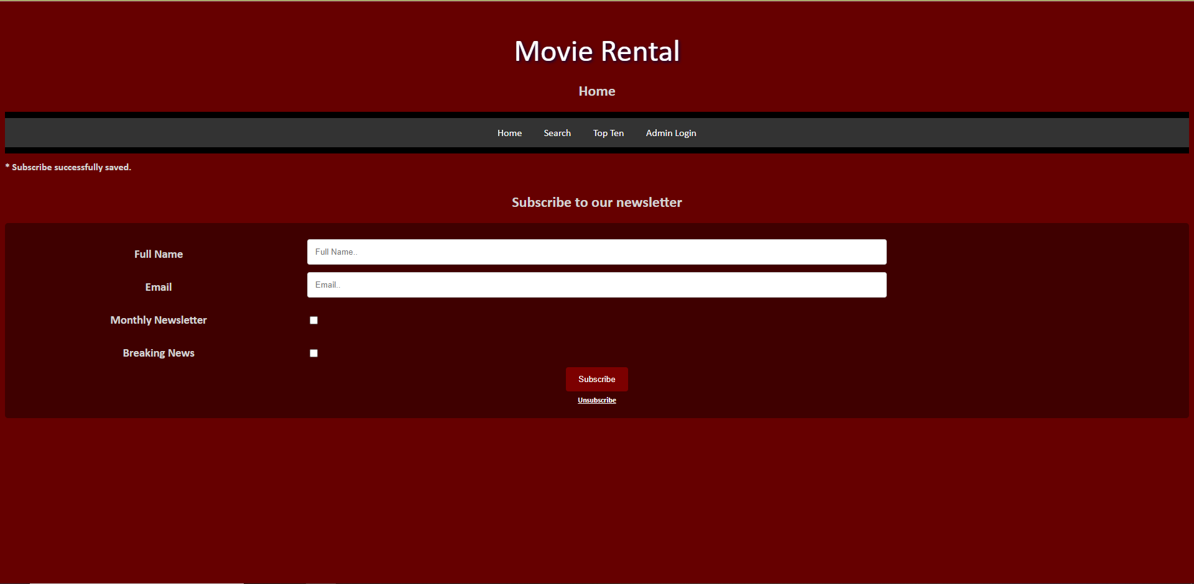

Figure 2

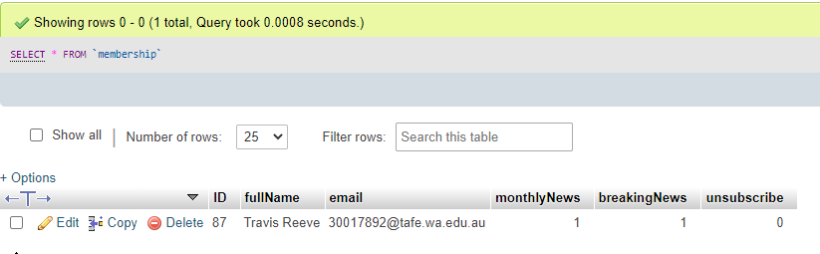

Figure 3

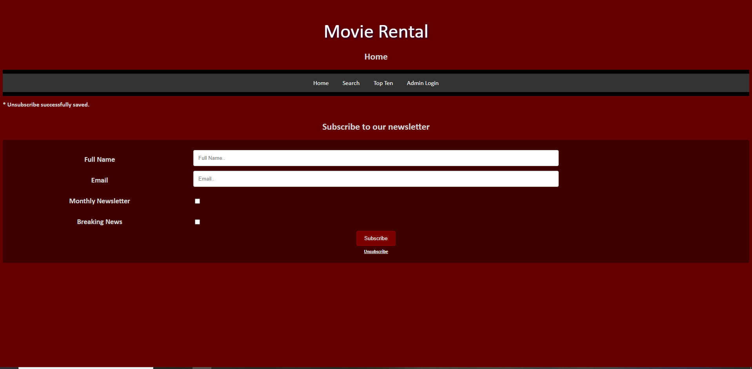

Figure 4

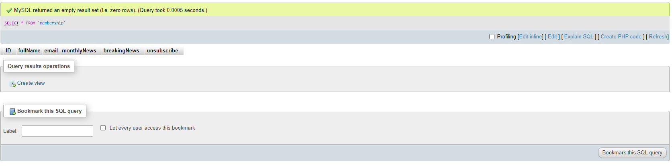

Figure 5

